***“The work contained and presented here is my work and my work alone.” – Haardik Sharma***

**Question 1**- Use the data set “Freshmen.”  Take a random sample of size 50 and test the hypothesis that the “mean of the differences in individuals’ (µd) high school GPA and freshman year college GPA is zero.

Solution1-

1. We have loaded the Freshmen.jmp file into the JMP Pro Application.
2. As per ask of the question we have taken a random sample of size 50 using the following path.

Rows > Row Selection>Select Randomly>Provide Sample size of 50.

1. After this we select the inverse of these 50 rows from the population of 100 and select Exclude.
2. 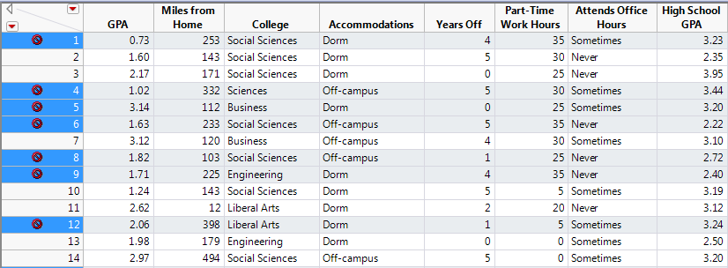Select Matched Pair option under the ANALYZE tab and select the following:

We have used Matched Pair here because, The Matched Pairs compares the difference between two variables for the same record using a paired t-test. In this problem we want to the graph to display ‘mean of the differences in individuals’ (µd) high school GPA and freshman year college GPA.

1. We get the following Difference Graph post this operation.

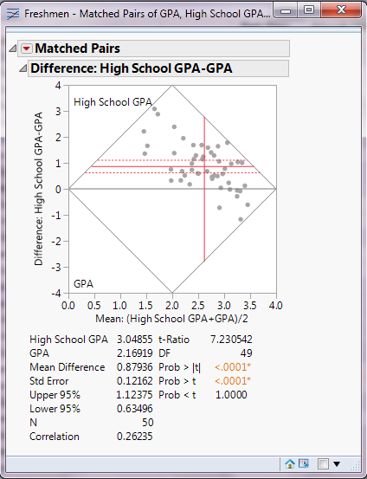

1. Now as per the problem statement our hypothesis is:

H0: (µd) = (µh) - (µf) = 0

HA: (µd) = (µh) - (µf) ≠ 0

Here **µh** is Mean for High School GPA and **µf** is Mean for Freshmen GPA.

Since the Alpha Level is 0.05(this value is by Default, if required we can change it) which is much higher than the P-value, we cannot accept this hypothesis.

Which means that the alternate hypothesis is accepted which states that the ‘mean of the differences in individuals’ (µd) high school GPA and freshman year college GPA is **NOT** zero.

**Question 2** - Use the data set “training data set 1” and test that the mean of P1 is greater for Big Cities than for other (cities). For what alpha level would you accept the hypothesis?

Solution –

1. We have loaded the ‘training data set 1’ file into the JMP Pro Application.
2. Since we have to test the mean of continuous ‘P1’for two categorical groups- Big Cities and Other, we will use ‘Fit Y by X’ option to examine this relationship. This graph demonstrates such data in a very convenient way. We can select this graph from the following path:
   1. 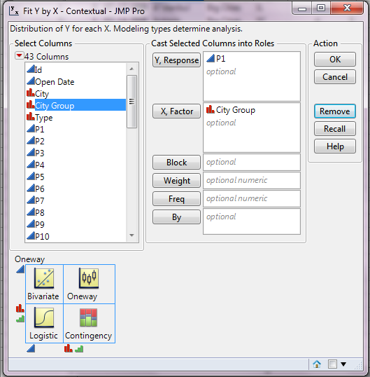Analyse > Fit Y by X > refer this data:
3. We will get this graph: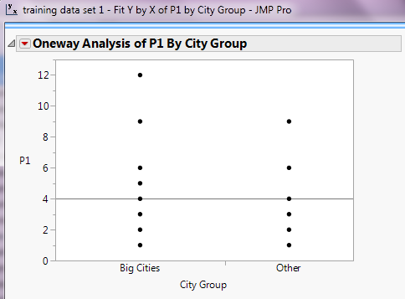
4. To analyse this graph we will perform t-test on this by selecting the relevant t-test option from the red drop down. We will get this distribution graph.

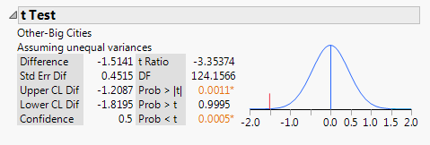

1. Now as per the problem statement our hypothesis is:

H0: **µb > µo** i.e. **µb - µo > 0** or **µo - µb < 0**

HA: **µb ≤ µo**

Here **µb** is Mean for P1 of Big Cities and **µo** is Mean for P1 of Other Cities

1. Now as per the requirement we need to find the Alpha Level so that our hypothesis is accepted.

**So in order to accept this hypothesis our Alpha value should be greater than P-value (0.0005)**

**Question 3** - Use the data set “training data set 1” and present the distribution details with the histogram present horizontally.

Solution –

1. We have loaded the ‘training data set 1’ file into the JMP Pro Application.
2. Select Analyze > Distribution
3. Select the following data :
4. 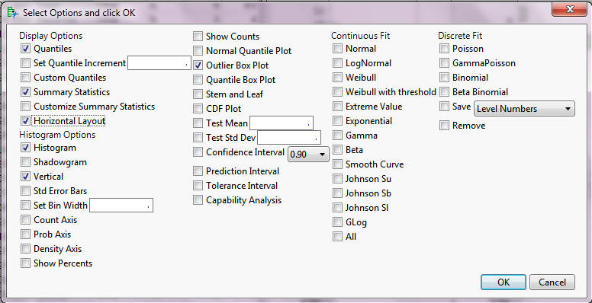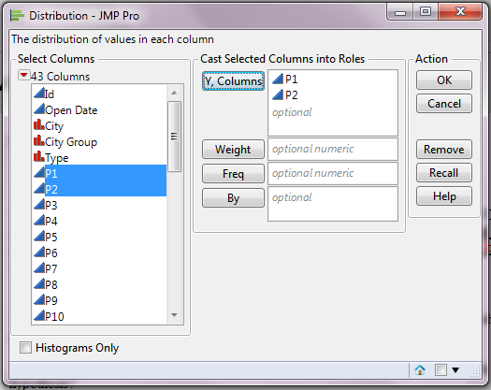Select the following Horizontal Option.
5. 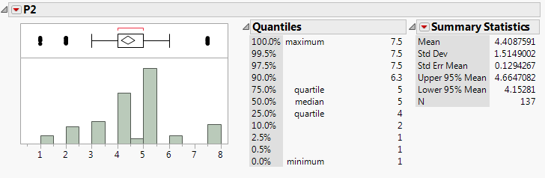**These are the required Histogram details(when aligned horizontally)** :

